---------ARRAY PROGRAMS-----------

1. WAP to find the length of an Array or size of an array
2. WAP to print the elements present in an Array using for loop
3. WAP to print the elements present in an Array using for each loop
4. WAP to find the average of the elements in a given Array
5. WAP to copy one Array elements to another Array in the reverse order
6. WAP to merge two Array elements
7. WAP to find whether the given element is present in an Array or not (Linear Search)
8. WAP to perform the left Shift in an Array
9. WAP to perform the left shift in an Array n number of times (n is user specified value)
10. WAP to perform the Right Shift in an Array
11. WAP to perform the Right shift in an Array n number of times (n is user specified value)
12. WAP to remove the duplicate elements from a given Array
13. WAP to print the duplicate elements present in a given Array
14. WAP to find the frequency or occurrence of an element in a given Array (How many times an element is repeated in a given array)
15. WAP to print the maximum frequency element in a given Array
16. WAP to sort a given Array in Ascending Order
17. WAP to sort a given Array in Descending Order
18. WAP to swap the first half and the Second Half elements in a given array
19. WAP to find the largest element in a given Array
20. WAP to find the Second largest element in a given Array
21. WAP to find the smallest element in a given Array
22. WAP to find the Second smallest element in a given Array
23. WAP to move all zeroes to the end of an Array
24. WAP to create a 2D array(Matrix)
25. WAP to add Two matrices
26. WAP to multiply Two Matrices
27. WAP to find the transpose of a given matrix

------STRING PROGRAMS------

1. WAP to find the length of a given String or count the no. of characters present in a given String
2. WAP to print the vowels and consonants in a given String
3. WAP to replace all the vowels in a given String with white space
4. WAP to count the no. of spaces present in a given String
5. WAP to reverse a String
6. WAP to check whether the given the String is Palindrome or not
7. WAP to remove the duplicates from the given String
8. WAP to find the frequency of character in a given String
9. WAP to convert the given String into lower case
10. WAP to convert the given String into Upper case
11. WAP to find the largest word in a given String
12. WAP to find the smallest word in a given String
13. WAP to remove the white spaces from a given String
14. WAP to swap the first and last word in a given String
15. WAP to reverse the words in a given String without reversing the words themselves
16. WAP to reverse each and every word in a given String
17. WAP to find the frequency of each and every word in a given String
18. WAP to check the given word is present inside a given String or not
19. WAP to check whether the given String is Anagram or not
20. WAP to find the substring of a given String
21. WAP to compare two strings lexicographically.  
    (Two strings are lexicographically equal if they are the same length and contain the same characters in the same positions)
22. WAP to replace a specified character with another character.
23. WAP to find the longest Palindromic Substring within a string.

----Number Programs and Pattern Programs----

1. WAP to swap two numbers with the help of Third variable
2. WAP to swap two numbers without using Third variable
3. WAP to Reverse the given Number
4. WAP to print the Palindrome Numbers from m to n
5. WAP to check whether the given number is ArmStrong(narcissistic number) number or not.
6. WAP to print the factorial of the given number
7. WAP to print the Prime numbers from m to n
8. WAP to print the fibbonacci series
9. WAP to print the Tribonacci series
10. WAP to print the perfect squares from m to n
11. WAP to find x power n (x and n are user given values)
12. WAP to print the below patterns
13. 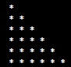
14. 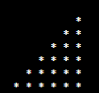
15. 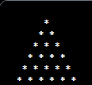
16. 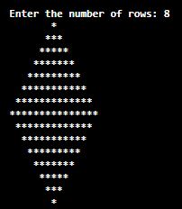
17. 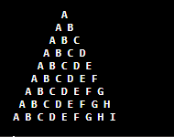
18. 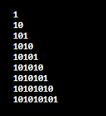

7.

